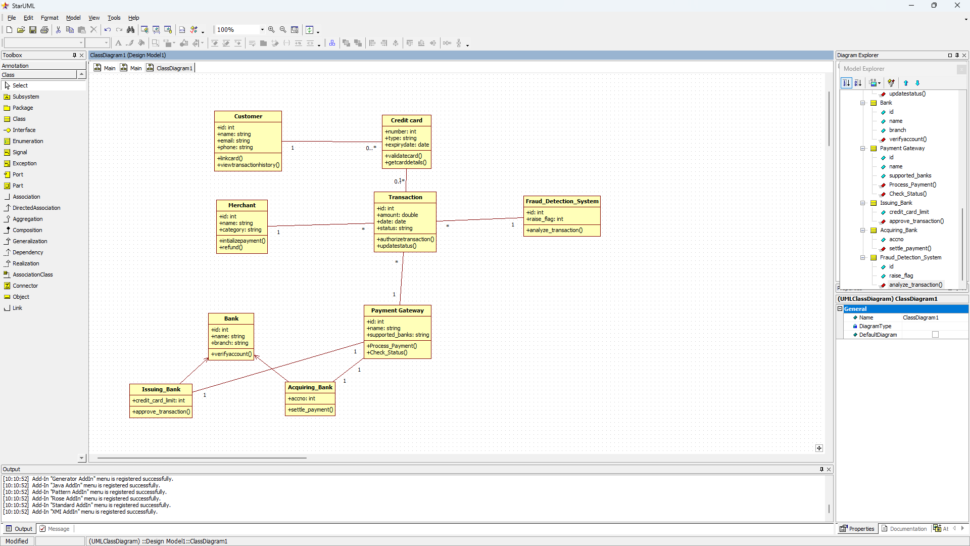

CREDIT CARD PROCESSING SYSTEM

HOTEL MANAGEMENT SYSTEM

STOCK MAINTENANCE SYSTEM

LIBRARY MANAGEMENT SYSTEM

PASSPORT AUTHENTICATION SYSTEM